**MAKE** fund

EPFL, Vice-presidency for Education.

**Call for proposal:**

The challenges that students will be confronted with once they graduate are becoming increasingly complex. Besides requiring solid background in a core discipline, they demand an ability to work at the intersection between a range of fields.

The MAKE fund supports EPFL projects giving students an opportunity to confront themselves with the challenges posed by interdisciplinarity during their training, giving them a head start in developing the skills they will need in their professional future. It aims at facilitating group projects involving students across sections and implying prototyping.

Submitted projects shall (please read as well the “evaluation criteria” document for more information):

* give students freedom to develop their own ideas and solutions
* participate in the reinforcement of students’ skills and knowledge in their discipline thanks to practical implementation
* expose students to interdisciplinarity thanks to the diversity of tasks/disciplines involving students coming from various sections of the school
* give students the opportunity to acquire transversal skills such as team-working and project management among others

Projects can be initiated by students (bottom-up) or Professors (top-down). Three main categories of projects are identified:

* **MAKE embryo** - Interdisciplinary projects that are at a very early stage but requiring small support to start. For this category of projects, please do not fill up this form. The process we propose is to have a discussion with Julien Delisle and if your project fits the MAKE objectives, you can receive basic support such as access to makerspaces and a small budget in order to build a first pre-prototype. After 1 to 2 semesters as a MAKE embryo, you can fill up a complete submission for more support.
* **Interdisciplinary project similar to a course –** One main laboratory endorses supervision of a project involving students from multiple sections. The project must be open ended and give room for students to develop their own ideas and solutions.

Ex: Student robot contest.

* **Highly interdisciplinary projects -** Projects involving numerous different subprojects carried by students in different formats (bachelor projects, master projects, non-credited projects) and coordinated towards a same goal. These projects are more complex in terms of coordination and students organize themselves via a student association.

Ex: Swiss Solar Boat, EPFL Rocket Team projects.

Due to the complexity involved in launching interdisciplinary projects, it is strongly recommended to design projects aiming at lasting several years (yearly project format repeated several times or one project running over several years). Even though projects are designed for a multi-year period, a yearly presentation and validation of the support will be needed.

We also recommend that you **contact the MAKE coordinator** Julien Delisle to assist you in preparing your project application.

**Submission process**

Two calls for projects are open. Deadline for submission are:

* June 3rd 2024 for semester and yearly projects starting in September 2024
* November 4th 2024 for semester and yearly projects starting in February 2025

Evaluation of the projects will be made by a committee representing EPFL (the MAKE committee) composed of:

* The Vice-President for Education
* 1 representative of each Faculty
* 1 student representative
* The operational director of the career and transversal skills center

**The selection will be made on the basis of the following documents:**

* Mandatory - This document - the main written and detailed submission **signed**
* Facultative - Any annexes you have

*For* ***new projects******only*** *submitting for the first time - please provide as well:*

* Mandatory - A 3min maximum video presenting the project, with a focus on your motivation and the vision for your project

*For* ***ongoing projects*** *that want to renew funding only – please provide as well:*

* Mandatory - The 2 pager activity report of the last semesters - Please use the word template in the submission folder
* Facultative - You can provide a 3min max video as well but it is not mandatory. For this video we suggest to provide the broad picture of the project at the moment of the submission:
  + What are the achievements/difficulties you had last two semesters,
  + At what stage is the project right now
  + What do you plan to develop next semesters with the funding you are requesting

For submission, send your application for evaluation by the MAKE committee (contact: [*julien.delisle@epfl.ch*](mailto:julien.delisle@epfl.ch)*)*

|  |  |
| --- | --- |
| General information | |
| Project title |  |
| Project category  *What type of project are you willing to develop?*  *.*  *What is the format of your project?* | ☐ Interdisciplinary projects with one main laboratory (support order of magnitude 5’000 CHF per semester)  ☐ Highly interdisciplinary projects with many laboratories and a student association (support order of magnitude 20’000 CHF per semester)  ☐ MAKE embryo – if you want to launch a new MAKE project, please do not fill up this form directly and contact the MAKE coordinator Julien Delisle |
| Disclaimer  *It is important for the project responsible to read this disclaimer before signing here under.* | *Please do not fill up this rubric and keep it intact*  It is important to clarify the nature of the support provided through the MAKE initiative. Beyond the support in the setting up phase of the project and the financing granted to the selected projects, the support you can expect from MAKE concerns the access to shared spaces and competences (makerspaces and coaches) to accompany the students in their achievements.  Whenever possible and time permits, the responsible of the MAKE initiative will naturally seek to guide students and project leaders to find ad-hoc solutions for their specific problems.  **However, it is important to emphasize that the professor and the coordinator in charge of the project (here under) has the operational responsibility for the project, and they have to ensure proper scientific endorsement, organization and logistics, legal issues, insurances issues, off-campus activities - or more generally the project follow-up and student’s safety - are handled properly.** |
| Main Applicant(s) – **name and signature**  *Professor in charge of the project and its operation. This professor has to ensure proper scientific endorsement, organization and logistics, and make sure that legal questions, insurances and off-campus activities - or more generally project follow-up and student’s safety- are handled properly* |  |
| EPFL operational responsible- coordinator – **name and signature**  ***EPFL employee*** *in**charge of the project alongside the main applicant.*  *You can have multiple coordinators to share the workload (for example a technical and an administrative coordinators).*  *Depending on the project expectations, the role of coordinator**can be quite time consuming.* |  |
| Student(s) responsible or president of the association – **name and signature**  *If a student association exists, please ensure the student(s) leader(s) sign here.*  *The student(s) leader(s) of a MAKE project bears some responsibility. By signing here, they understand that they can be hold responsible of misconduct. Especially in case of lack of transparency with the Professor and the coordinator in charge.*  *You can have multiple students signing if responsibilities are shared in the team (max 5 students with their respective role)* |  |
| Project Description and timeline  *Provide an image of a visual timeline of the upcoming semesters you are asking financial support for* | |
| Timeline - Project history  ***What happened in the past? Where does the project come from?***  *Has the project already been run at EPFL, if yes, when (please give some indication relative to synergies between past event and current proposition – transfer, use of built expertise, etc)* | *Please be concise to explain where the project comes from (past achievements if any, motivation). Max 200 words* |
| Timeline - Project intermediate milestones  ***What will happen in the upcoming academic year?***  *Define project planning and main milestones.*  *It is strongly advised for MAKE projects to properly define intermediate milestones and what will be expected from students* | *Please use bullet points and be concise* |
| Timeline - Project final objectives in terms of developments  ***What do you expect as final realization from the students in one year time?***  *Please describe the main final objectives of the project.*  *These objectives will be taken back in 12 months in the mandatory activity report to renew funding* | *The MAKE committee expects three main objectives focus on developments only:*   * *Main objective 1, expected at the end of the project, in terms of scientific/engineering/architectural* ***development*** * *Main objective 2, expected at the end of the project, in terms of scientific/engineering/architectural* ***development*** * *Main objective 3, expected at the end of the project, in terms of effort* ***to reduce the ecological footprint of the project*** |
| Timeline - Project perceived evolution  ***What is the vision over multiple years?***  *Shall the project be supported, how do you see its evolution over the years (repetition of same format for different editions, evolution of the format, other?)*  *Are there any long-term objectives?* | *Please be concise to explain where the project comes from (past achievements if any, motivation). Max 200 words* |
| Team description  *Please describe the team of students you have and expect to build in the upcoming semesters* | *Please be concise and fill up the following bullet points*   * *(****for ongoing project renewing funding only****) How many students where involved in the project last year and from which sections? Is there a student association in place to support the realization of the project? You can provide an image/info-graphic* * *Was the idea of the original project students of professor driven?*   + *If students driven, describe in a few words the effort to ensure proper scientific supervision*   + *If professor driven, describe in a few words the effort to recruit students* * *How many students do you expect to involve next year?* |
| Learning objectives and pedagogical interventions  *Please list here the learning objectives of your project. What will the students learn by participating in your project?*  *You can differentiate technical skills and professional skills*  *Do you plan any specific interventions (workshops, seminar, other) to facilitate the learning of these objectives? If yes, please provide explanations* | *Pleae use bullet points and be concise* |

Project Stakeholders

*Please provide an image to visually represent the different stakeholders involve in the project*

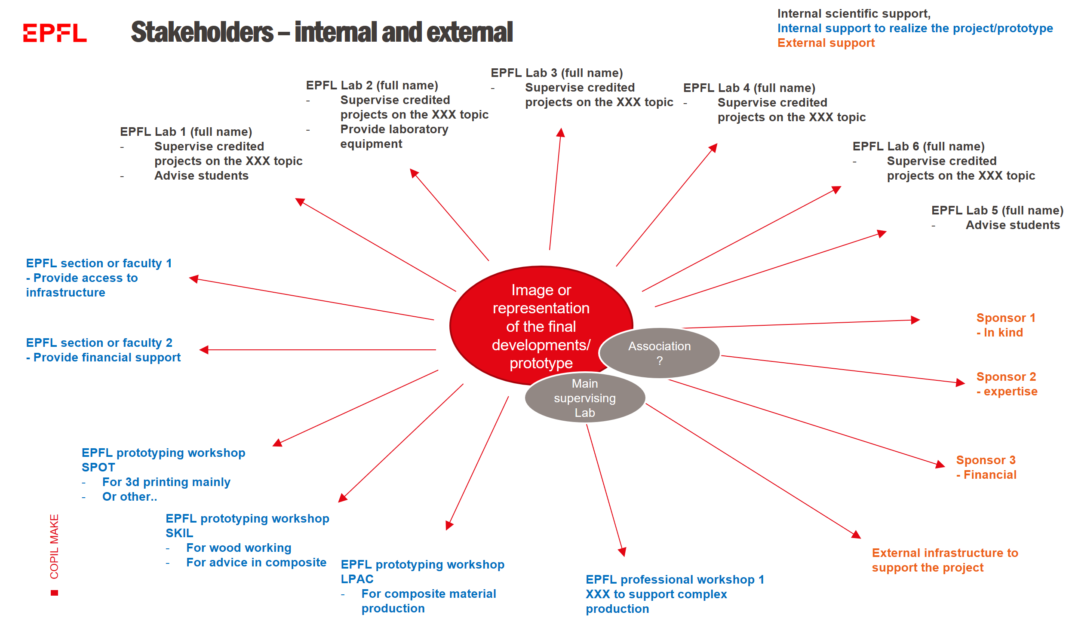

|  |  |
| --- | --- |
| Stakeholders -EPFL supporting laboratories  *List the different topics and Professors who will be involved in supervising the students with credited projects (please differentiate the Professors who have accepted from the ones who might be interested in the future)*  *Please mention what will be the contribution of each laboratory* | *Please use bullet points and be concise* |
| Stakeholders - EPFL supporting faculties/sections/VPs  *List here other internal stakeholders that mentioned to be ready to support your project.*  *What is the level of support from the different faculties/sections/VPs and what is the level of commitment (please provide support letter if relevant)* | *Please use bullet points and be concise* |
| Stakeholders - EPFL prototyping workshops  *List here all the prototyping workshops you will need.*  *If you plan to use specific infrastructure or professional workshops, mention if you contacted them and if they validated to support your project* | *Please use bullet points and be concise* |
| Stakeholders – external sponsors/partners  *List here external stakeholders that mentioned to be ready to support your project.*  *What is the level of support, financial/experise/in-kind/prototyping?* | *Please use bullet points and be concise* |
| Project organization  *Provide a scheme and written comments to explain the way the team will be organized to reach project objectives and interact with all the stakeholders mentioned above*  *Please include the stakeholders but also the student association, the Professor and the coordinator in charge* | *You can provide comments for the scheme here using bullet points* |

|  |  |
| --- | --- |
| Financial information  A separate file describing this section on financial information is possible | |
| Costs  *Describe here the total budget estimated for your project to succeed* | *Please use bullet points and be concise* |
| Required support  *Describe wished financial support and the way it will be spend..*  *In particular, describe the following:*   * *How much will be used for project supervision (salary, travel expenses for supervisors, other)?* * *How much will be used for prototype development (consumables, materials, other resources)?*   *The MAKE support cannot be spend for other types of expenses*    *If the project is ambitious, we* ***advise a strong involvement of the coordinator. If not paid by MAKE, please indicate if the laboratory in charge will pay part of the salary of the coordinator to ensure coordination time for the project.*** | *Please use bullet points and be concise* |
| Remaining to find  *Describe here how much money is remaining to find to reach the total budget.*  *How much did you secured through sponsoring already?*  *Is there potential future partners you identified?* | *Please use bullet points and be concise* |

|  |  |
| --- | --- |
| Feasibility | |
| Available resources and infrastructure  *List the available resources (internal and external) to support your project.*  *In particular, if your project requires specific infrastructure for production or testing, list them here and the solution you envision.* | *Please use bullet points and be concise* |
| Identified challenges  *List the identified challenges and risks of your projects and how you plan to mitigate them*  *If the projects involves off-campus activities, please describe them here and the way to mitigate the risks associated* | *Please use bullet points if possible* |

Annex – other responsibilities – not mandatory

*This section describes other key roles identified in previous interdisciplinary projects. By providing names of students/EPFL employee endorsing these roles, you provide contact points that will be in contact with the relevant EPFL stakeholders. You can have multiple coordinators in one rubric, just explain the respective roles*

|  |  |
| --- | --- |
| Prototyping/technical coordinator  Name  *Having the overview of the technical development of the prototype. What will be the main development steps? What infrastructures, equipment, coach and other resources will be needed?*  ***This coordinator can be an experienced student (under the supervision of the coordinator) and will be the main contact point for the prototyping coaches and for the professional workshops to ensure coordinated use of the prototyping network****.* |  |
| Sponsoring and communication responsible  Name  *Having the overview of the sponsoring and communication for the project.*  ***This coordinator can be***  ***an experienced students (under the supervision of the coordinator) and will be the main contact point for Mediacom and other parties involved in EPFL official communication. It will also be the contact point for sponsoring questions****.* |  |
| Pedagogical/ transversal skills supervisor  Name  *Having the overview of the workshops and other interventions to support the learning of the students throughout the project.*  ***This coordinator can be***  ***an experienced students (under the supervision of the coordinator) and will be the main contact point for organizing workshops (and other pedagogical interventions) and facilitate the learning of the students in the team*** |  |