**MAKE** fund

EPFL, Association Vice-Presidency for Education.

**Call for proposal:**

The challenges that students will be confronted with once they graduate are becoming increasingly complex. Besides requiring solid background in a core discipline, they demand an ability to work at the intersection between a range of fields.

The MAKE fund supports EPFL projects giving students an opportunity to confront themselves with the challenges posed by interdisciplinarity during their training, giving them a head start in developing the skills they will need in their professional future. These projects aim at mimicking a professional/industrial environment facilitating team projects and requiring prototyping/product development.

**For details regarding the submission process (deadlines etc..) and the evaluation criteria you can read the following web page:** [**https://make.epfl.ch/wiki/public/admin/make_selection_process**](https://make.epfl.ch/wiki/public/admin/make_selection_process)

Projects can be initiated by students (bottom-up) or Professors (top-down). Three main categories of projects are identified:

* **MAKE embryo** - Interdisciplinary projects that are at a very early stage but requiring small support to start. For this category of projects, please do not fill up this form. The process we propose is to have a discussion with Julien Delisle (MAKE projects coordinator) and if your project fits the MAKE objectives, you can receive basic support such as access to makerspaces and a small budget in order to build a first pre-prototype. After 1 to 2 semesters as a MAKE embryo project, you will be asked to fill up a complete submission for more support.
* **Interdisciplinary project with a single supervising laboratory –** One main laboratory endorses supervision of a project involving students from multiple sections. The project must be open ended and give room for students to develop their own ideas and solutions.

Ex: [Student robotic competition](https://make.epfl.ch/projects/45/make-robotic-competition).

* **Highly interdisciplinary projects -** Projects involving numerous different subprojects carried by students in different formats (bachelor projects, master projects, semester projects, non-credited “free-lance” projects) and coordinated towards a same goal. Multiple EPFL laboratories are involved in coaching/supervising the student team. These projects are more complex in terms of coordination and students organize themselves via a student association.

Ex: [Swiss Solar Boat](https://make.epfl.ch/projects/15/make-swiss-solar-boat), [EPFL Rocket Team](https://make.epfl.ch/projects/rocket-team).

Due to the complexity involved in launching interdisciplinary projects, it is strongly recommended to design projects aiming at lasting several years (yearly project format repeated several times or one project running over several years).

We also recommend that you **contact the MAKE coordinator** Julien Delisle (julien.delisle@epfl.ch) to assist you in preparing your project application.

|  |  |
| --- | --- |
| General information | |
| Deadlines | *The submission deadline to receive funding for the academic year 2025-26 is set for the* ***12th of June 2025*** |
| Project title |  |
| Project category  *What type of project are you willing to develop?*  *.*  *What is the format of your project?* | ☐ Interdisciplinary projects with one main laboratory (support order of magnitude 5’000 CHF per semester)  ☐ Highly interdisciplinary projects with many laboratories and a student association (support order of magnitude 20’000 CHF per semester)  ☐ MAKE embryo – if you want to launch a new MAKE project, please do not fill up this form directly and contact the MAKE coordinator Julien Delisle |
| Disclaimer  *It is important for the project responsible to read this disclaimer before signing here under.* | *Please do not fill up this rubric and keep it intact*  It is important to clarify the nature of the support provided through the MAKE initiative. Beyond the support in the setting up phase of the project and the financing granted to the selected projects, the support you can expect from MAKE concerns the access to shared spaces and competences (makerspaces and coaches) to accompany the students in their achievements.  Whenever possible and time permits, the responsible of the MAKE program will naturally seek to guide students and project leaders to find ad-hoc solutions for their specific problems.  **However, it is important to emphasize that the professor and the coordinator in charge of the project (here under) have the operational responsibility for the project, and they must ensure proper scientific endorsement, organization and logistics, legal issues, insurances issues, off-campus activities - or more generally that the project follow-up and the student’s safety - are handled properly.** |
| Main Applicant(s) – **name and signature**  *Professor in charge of the project and its operation. This professor has to ensure proper scientific endorsement, organization and logistics, and make sure that legal questions, insurances and off-campus activities - or more generally that the project follow-up and student’s safety- are handled properly* |  |
| EPFL operational responsible- coordinator – **name and signature**  ***EPFL employee*** *in**charge of the project alongside the main applicant.*  *This person is working closely with the students and supports the supervising professor in ensuring that the project is academically/pedagogically valuable and operationally feasible and safe.*  *You can have multiple coordinators to share the workload (for example a technical and an administrative coordinator).*  *Depending on the project expectations, the role of coordinator**can be quite time consuming.* |  |
| Student(s) responsible or president of the association – **name and signature**  *If a student association exists, please ensure the student(s) leader(s) sign here.*  *The student(s) leader(s) of a MAKE project bears some responsibility. By signing here, they understand that they can be hold responsible of misconduct. Especially in case of lack of transparency with the Professor and the coordinator in charge. They have the responsibility to respect the legal and financial framework in place for MAKE associations*  *You can have multiple students signing if responsibilities are shared in the team (max 5 students with their respective role)* |  |
| Project Description and timeline  *Provide an image of a visual timeline of the upcoming years you are asking financial support for* | |
| Timeline - Project history  ***What happened in the past? Where does the project come from?***  *Has the project already been run at EPFL, if yes, when?* | *Please be concise to explain where the project comes from (past achievements if any, motivation). Max 200 words* |
| Timeline - Project intermediate milestones  ***What will happen in the upcoming academic year?***  *Define project planning and main milestones for the next academic year.*  *It is strongly advised for MAKE projects to properly define intermediate milestones to structure the project during the year.* | *Please use bullet points and be concise* |
| Timeline - Project final objectives  ***What do you expect as final realization from the students next academic year and in the next three years?*** | *Please use bullet points and be concise*  *Final objectives for the next academic year*  *Final objectives for the next three years* |
| Timeline - Project perceived evolution  ***What is the vision over multiple years?***  *Shall the project be supported, how do you see its evolution after the next three years support (repetition of same format for different editions, evolution of the format, other?)*  *Are there any long-term objectives?* | *Please use bullet points and be concise*  *Long term (over three years) objectives* |
| Team description  *Please describe the team of students you have and expect to build in the upcoming semesters* | *Please be concise and fill up the following bullet points*   * *How many students are* ***already*** *involved in the project and from which sections? Is there a student association in place to support the realization of the project? You can provide an image/info-graphic* * *Was the idea of the original project students of professor driven?*   + *If students driven, describe in a few words the effort to ensure proper scientific supervision*   + *If professor driven, describe in a few words the effort to recruit students and ensure good student’s motivation and leadership on the project* * *How many students do you expect to involve next year? Do you expect to increase the size of the team?* |
| Learning objectives and pedagogical interventions  *Please list here the learning objectives of your project. What will the students learn by participating in your project?*  *You can differentiate technical skills and professional/transversal skills*  *Do you plan any specific interventions (workshops, seminar, peer to peer evaluation, feedback session, individual discussion, other) to facilitate the learning of these objectives? If yes, please provide explanations* | *Please use bullet points and be concise* |

Project Stakeholders

*Please provide an image to visually represent the different stakeholders involve in the project*

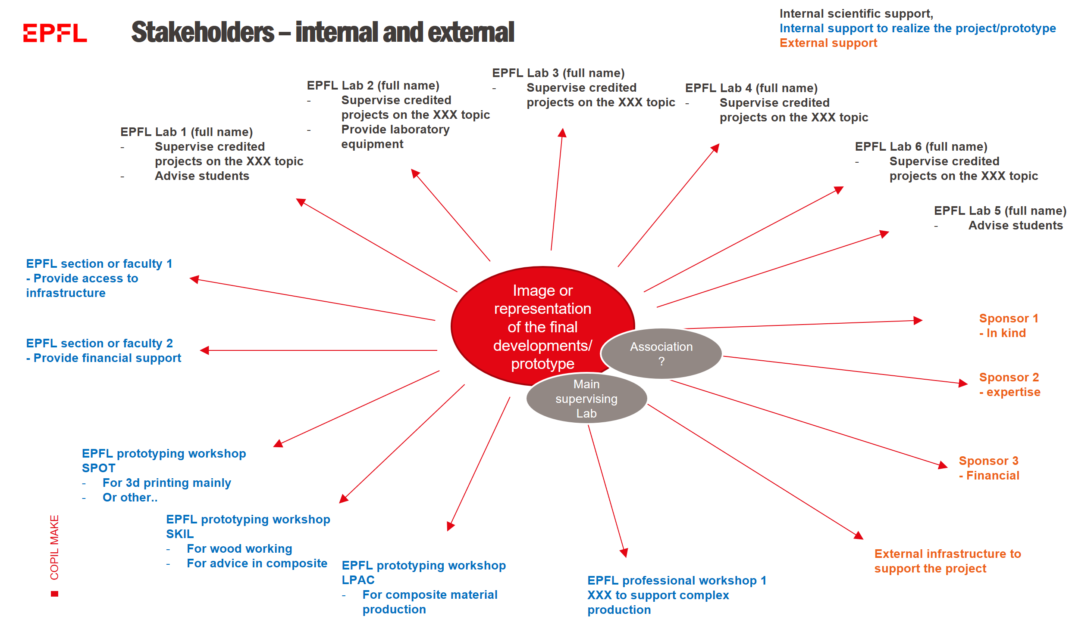

|  |  |
| --- | --- |
| Stakeholders -EPFL supporting laboratories  *List the different topics and Professors who will be involved in supervising the students with credited projects (please differentiate the Professors who have accepted from the ones who might be interested in the future)*  *Please mention what will be the contribution of each laboratory* | *Please use bullet points and be concise* |
| Stakeholders - EPFL supporting faculties/sections/VPs  *List here other internal stakeholders that mentioned to be ready to support your project.*  *What is the level of support from the different faculties/sections/VPs and what is the level of commitment (please provide support letter if relevant)* | *Please use bullet points and be concise* |
| Stakeholders - EPFL prototyping workshops  *List here all the prototyping workshops you will need.*  *If you plan to use specific infrastructure or professional workshops, mention if you contacted them and if they validated supporting your project* | *Please use bullet points and be concise* |
| Stakeholders – external sponsors/partners  *List here external stakeholders that mentioned to be ready to support your project.*  *What is the level of support, financial/experise/in-kind/prototyping?* | *Please use bullet points and be concise* |
| Project organization  *Provide a scheme and written comments to explain the way the team will be organized to reach project objectives and interact with all the stakeholders mentioned above*  *Please include the stakeholders but also the student association, the Professor and the coordinator in charge* | *You can provide comments for the scheme here using bullet points* |

|  |  |
| --- | --- |
| Financial information  A separate file describing this section on financial information is accepted | |
| Costs  *Describe here the total budget estimated for your project to successfully complete the project and to ensure the right working environment for the students to learn.* | *Please use bullet points and be concise* |
| Required support  *Describe wished financial support and the way it will be spend.*  *In particular, describe the following:*   * *How much will be used for project supervision (salary)?* * *How much will be used for prototype development (consumables, materials, other resources)?*   *The MAKE support cannot be spend for other types of expenses. If you plan to use this money differently you can describe it here and it will be evaluated by the committee*    *If the project is ambitious, we* ***advise a strong involvement of the coordinator. If not paid by MAKE, please indicate if the laboratory in charge will pay part of the salary of the coordinator to ensure coordination time for the project.*** | *Please use bullet points and be concise* |
| Remaining to find  *Describe here how much money is remaining to find to reach the targeted budget.*  *How much did you secured through sponsoring already?*  *Is there potential future partners you identified?* | *Please use bullet points and be concise* |

|  |  |
| --- | --- |
| Feasibility | |
| Available resources and infrastructure  *List the available resources (internal and external) to support your project.*  *In particular, if your project requires specific infrastructure for production or testing, list them here and the solution you envision.* | *Please use bullet points and be concise* |
| Identified challenges  *List the identified challenges and risks of your projects and how you plan to mitigate them*  *If the projects involves off-campus activities, please describe them here and the way to mitigate the risks associated* | *Please use bullet points if possible* |

|  |  |
| --- | --- |
| Sustainability  *We invite every MAKE project to reflect about the long-term future (2075) of their technological field, what should be done to ensure this future is desirable.*  *For instance, we might see climate change as an adverse consequence of oil-based technologies developed in the 19th century. What could have been done then to avoid climate change? What can we do today about emerging technologies to avoid future sustainability issues?* | |
| *If you have already started to reflect on such matters in the context of your project*  *Describe what you did and what you learned over the last academic year on this topic*  *Tell us about your plans to deepen these reflections over the next academic year* | *What has been done?*  *What are your plans to deepen these reflections?* |
| *If you have not started yet*  *Please confirm the students who will work on this presentation and will contact Michka Mélo*  *Please indicate during which public event (before July 2026) involving the whole team - and ideally sponsors - you will present your findings with a 10+min presentation* | ☐ *We understand that 2+ team members will have to invest 30+ hours before July 2026 to prepare a 10+min presentation, with the support of MAKE’s sustainability coach (contact:* [*michka.melo@epfl.ch*](mailto:michka.melo@epfl.ch)*)* |

Annex – other documents to provide - **mandatory**

*In annex of this submission, you need to provide the following documents:*

1. ***The activity report*** *of the ongoing academic year (if you were an ongoing project or an embryo project). The activity report is not mandatory for completely new projects.*
2. ***A 3min video*** *summarizing the project proposal and your vision and motivation*

*You can download a template of the activity report here*

*You can download a description of what is expected in the video here*

Annex – other responsibilities – not mandatory

*This section describes other key roles identified in previous interdisciplinary projects. By providing names of students/EPFL employee endorsing these roles, you provide contact points that will be in contact with the relevant EPFL stakeholders. You can have multiple coordinators in one rubric, just explain the respective roles*

|  |  |
| --- | --- |
| Prototyping/technical coordinator  Name  *Having the overview of the technical development of the prototype. What will be the main development steps? What infrastructures, equipment, coach and other resources will be needed?*  ***This coordinator can be an experienced student (under the supervision of the coordinator) and will be the main contact point for the prototyping coaches and for the professional workshops to ensure coordinated use of the prototyping network****.* |  |
| Sponsoring and communication responsible  Name  *Having the overview of the sponsoring and communication for the project.*  ***This coordinator can be***  ***an experienced students (under the supervision of the coordinator) and will be the main contact point for Mediacom and other parties involved in EPFL official communication. It will also be the contact point for sponsoring questions****.* |  |
| Pedagogical/ transversal skills supervisor  Name  *Having the overview of the workshops and other interventions to support the learning of the students throughout the project.*  ***This coordinator can be***  ***an experienced students (under the supervision of the coordinator) and will be the main contact point for organizing workshops (and other pedagogical interventions) and facilitate the learning of the students in the team*** |  |