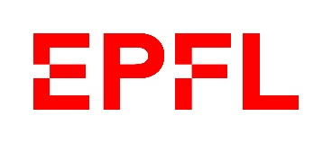

**Activity report MAKE projects**

**Title of the project + (optional) a picture**

1. State of advancement of the project and main realization of the academic year 2022-23. (max 500 words). For the three main objectives you listed in your last MAKE submission, please describe if they were achieved and if not, why?
   * *Main objective 1 of last submission, Description of achievement in terms of developments*
   * *Main objective 2 of last submission, Description of achievement in terms of developments*
   * *Main objective 3 of last submission, Description of achievement in terms of reducing the ecological footprint of the project*
2. Have the project objectives been meet? If not, why and what measures should be taken? (in a few sentences)

1. Number of involved students (credited or not) and from which section. Please fill up the following graphic (right click 🡪 modify data) :
2. EPFL laboratories involved in the project coaching and supervision – list of credited projects (bachelor/semester or master projects). Please fill up the table here under

|  |  |  |  |  |  |  |
| --- | --- | --- | --- | --- | --- | --- |
| LABORATORY | TITLE OF THE PROJECT | TYPE OF PROJECT | #ECTS credits | CONTRIBUTION TO THE PROJECT | NAME OF STUDENT | SCIPER |
| Projet 1 | Title of the project | Semester/bachelor/master ? |  | Which subsystem or part of the development have benefited from this project? |  |  |
| Projet 2 |  |  |  |  |  |  |
| … |  |  |  |  |  |  |

1. Describe how the MAKE budget has been spend (you can use a table in attachment)
2. (facultative) If pertinent, describe the effort provided to mitigate the main risks related to the safety of the students (in a few sentences)
3. (facultative) A word from the students - Providing a few quotes from the students regarding the impact the project had on them (the objective being to provide the MAKE committee with a feedback directly from the students).